**UNH SEDS**

**Final Launch Report**

October 2018



Authors

Charlie Nitschelm, Reilly Webb, Thomas Collins,

Grace Johnston, Charles Gould, Ross Thyne, Ester Yee

Matt Dodge, Silas Johnson, Carly Benik, Samantha Brady,

Andrew Hosman, Chase Eldredge, Collin Stroshine,

John Langer, Ryan Blatti, Tyler Landry

Advisor

Dr. Todd Gross

Table of Contents

List of Figures 3

List of Tables 4

List of Equations 4

Introduction 6

Abstract 6

Objectives of UNH SEDS 6

University Student Rocketry Competition 6

Goals 7

Constraints 7

Overall Rocket Configuration and Concept of Operations 7

Launch Operations and Safety Precaution Checklist 8

Technical Description of Vehicle Analysis 9

Static Test Fire Rig 9

Test Results 9

Test Comparisons 13

Flight Trajectory 15

Aether II 15

Further Testing 17

Nonlinear Optimization 18

Constraints 19

Finite Element Analysis 19

Build Process Validation 20

Model Rocket Class Iterations 20

Model Rocket v1 20

Model Rocket v2 20

Aether Class Iterations 20

Aether I 20

Aether II 21

Aether III 21

Aether IV 21

Aether V 22

Current Iteration (Detailed) 22

Aether VI 22

Electronics Documentation 24

Onboard Recovery Electronics 24

Parachute Design 26

Issues Encountered During the Manufacturing Process 29

Material Choice 29

Engine Choice 29

Parachute Choice 29

Final Assembly Procedure 29

Launch Dates 31

Safety and Launch Procedure Checklist 32

Overall Cash Flow 32

Detailed Cash Outflow 32

Launch Failure Mitigation 34

Improvement Cycle 34

Aerodynamic Models 35

Assumptions 35

Program Structure 36

Stability 36

Acceleration 38

Thrust 39

Mass 39

Drag 39

Trajectory 41

Model Verification 42

Updated Launch Dates 44

Current Completion Status 44

References 45

APPENDIX 45

MATLAB Simulation Code 45

Overall Simulation Function 46

Thrust 47

Mass 49

Drag of Sustainer 50

Drag of Booster and Sustainer 52

Acceleration of Sustainer 56

Acceleration of Booster 56

Caliber Function Code 57

# List of Figures

Figure 1. Rocket Components 7

Figure 11. Improvement Cycle 10

Figure 12 Trapezoidal Fin Model 13

Figure 13. Aether IV Caliber 14

Figure 14. Aether IV Launch Simulation 18

Figure 15: Model verification using Aether IV rocket 19

Figure 2. STFR test of booster engine 20

Figure 3. Load cell calibration 21

Figure 4. Booster Engine Response 22

Figure 5. Sustainer Engine Response 22

Figure 6. Engine Impulse vs Time 23

Figure 7. Experimental Data vs Cesaroni Supplied Data 24

Figure 8. Aether 2 Trajectory Comparison 26

Figure 9. Aether 2 Velocity Comparison 27

Figure 10. Aether 2 Stability 28

Figure 16. Optimization of Aether VI Dimensions 29

Figure 17. Centering Ring FEA 30

Figure 18. Booster Fins 33

Figure 19. Sustainer Fins 34

Figure 20. Nose Cone 34

Figure 21. Duel deployment basic design 35

Figure 22. Electronics schematics of the TeleMega GPS 36

Figure 23. Parachute Descent Speeds 37

# List of Tables

Table 1. Surface Roughness 23

Table 2. Aether IV Apogee Predictions 26

Table 3. Solid Textile Parachutes 34

# List of Equations

Equation 1 12

Equation 2 12

Equation 3 13

Equation 4 13

Equation 5 14

Equation 6 15

Equation 7 15

Equation 8 16

Equation 9 16

Equation 10 16

Equation 11 17

Equation 12 17

Equation 13 17

Equation 14 17

Equation 15 18

Equation 16 38

Equation 17 39

# Introduction

## Abstract

Members of UNH SEDS are designing, manufacturing, and launching a high powered multi-stage rocket for the SEDS University Student Rocketry Competition. Collegiate rocketry teams will be competing nationally in the Fall of 2018, with points awarded to the rockets that achieve the highest altitude, are fully recoverable, and are backed by the strongest design methodology. Since our team is working from the ground up, UNH SEDS has taken a "first principles" approach towards reaching these goals. Once fundamental aerodynamic relationships were studied and understood, they were implemented to create models of flight dynamics, drag, and stability. A static test fire rig was constructed to obtain experimental thrust curve data from the engines; further increasing the accuracy of our simulated trajectories. Driven by both manufacturing and competition constraints, our models were then used to optimize nose cone, body tube, and fin dimensions. Eight rocket iterations have been designed and launched. We have analyzed the flight data from each launch to continuously improve and learn important lessons out in the field that could not have been gathered from theory and simulations alone. The bulk of this report is to give a detailed view of taking our final rocket design into manufacturing, the problems encountered, and a greater detailed view in ensuring a safe, reliable flight.

## Objectives of UNH SEDS

Students for the Exploration and Development of Space (SEDS) is a national, student-based organization that enables university students to get involved in space related projects. A chapter of SEDS has was founded at UNH in the Fall of 2017.

The mission of UNH SEDS is to provide a platform for UNH students to form multi-disciplinary teams and pursue space-focused outreach, networking events, and engineering projects.

The 2017-2018 school year and the beginning of the Fall semester of 2018 was dedicated to design a rocket to compete in the University Student Rocketry Competition in October 2018. Students from all classes and majors dedicated themselves to learn the insider view of high power rocketry to be able to place with some of the top rocketry team in the country.

## University Student Rocketry Competition

The USRC is an annual competition hosted by SEDS-USA to challenge students, to design, build, and launch a multi-stage rocket with a standardized altimeter to the highest possible altitude. The judging panel includes professionals from within the aerospace industry. Winning teams will be awarded a cash prize as well as free attendance to the SEDS SpaceVision 2018 conference. Teams can launch at a field close to their university as long as they are witnessed by an independent party. However, teams can also meet up to organize a regional launch. Points are awarded by the judges based on the following criteria:

### Goals

1. Design and launch a high-powered rocket to achieve **maximum altitude** (at least 3000 feet)
2. Implement a comprehensive recovery system, such that the rocket is fully reusable

### Constraints

1. Total combined engine impulse must not exceed **640.0 N-s**
2. The rocket must have *at least* two propulsive stages
3. Time: Launch window closes **October 12th, 2018**
4. Budget: $4563.0 from the UNH ME department and Parents Association

## Overall Rocket Configuration and Concept of Operations

A section-view model of the rocket configuration is shown below in Figure 1. This is a high-level description of the major components that will be frequently referenced throughout the remainder of the report.

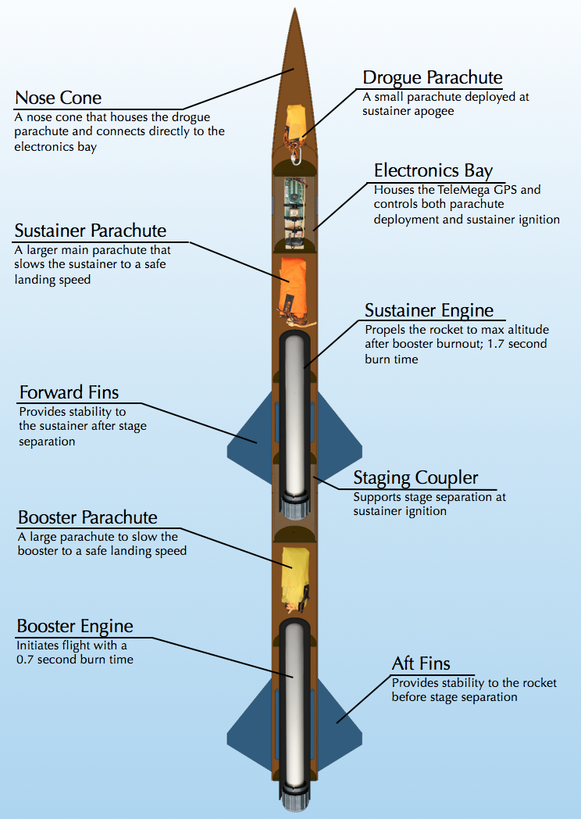

Figure 1. Rocket Components

Both engines are solid-propellant rocket motors manufactured by Cesaroni. Solid engines were chosen for simplicity and were purchased instead of being custom built. Next year UNH SEDS will attempt to manufacture their own hybrid rocket engines.

The TeleMega GPS/Altimeter system used will be referred to as the flight computer. The flight computer, located in the electrical bay (e-bay), sends electrical signals at various preprogrammed events. Current is sent to three individual ignitors; one that initiates the firing of the sustainer engine and two that light ejection charges for deploying the parachutes.

The booster engine is the first engine to fire; ignited manually from a safe distance using a custom ignition switch. Booster burn-out is followed be stage separation, then sustainer ignition. Decoupling the two stages is achieved by drag separation, with increased pressure from sustainer ignition acting as a fallback. The booster parachute then deploys, carrying the booster body tube and booster engine safely to the ground.

The sustainer body tube continues upward until the rocket reaches a maximum altitude, where the flight computer triggers an ejection charge at the appropriate time by evaluating altimeter data. The ejection charge pressurizes the area above the electrical bay, forcing off the nose cone and deploying the drogue parachute. The drogue is a small parachute that works to slow the decent of the rocket to a controlled speed. At a predetermined altitude, the flight computer will send a signal to another ejection charge located in the aft end of the e-bay. This separates the sustainer body tube from the e-bay and deploys the main parachute; a much larger parachute that slows the rocket components considerably. This prevents significant damage from ground impact.

# Competition Flight Overview

## Onboard Recovery Electronics

Parachute deployment was the most difficult part of the project for the team. It was a challenge for much of the year to establish what electronics to use and how to effectively use them for successful recovery. Originally, using an accelerometer with a mini servo and Arduino was proposed to trigger each deployment. Ultimately, we found it was in the team’s best interest to use the TeleMega altimeter. The device can operate for dual-deployment as well as provide GPS tracking so that the rocket can be retrieved in the case of extensive drift during recovery. Our electronics bay is in the nosecone of our rocket on a plate held in with Styrofoam. On one side of the plate is the Telemega, and on the other is the, the Telemega battery, the switch to activate the Telemega and the SEDS-required beeper altimeter. The Telemega system is shown in Figure 22.

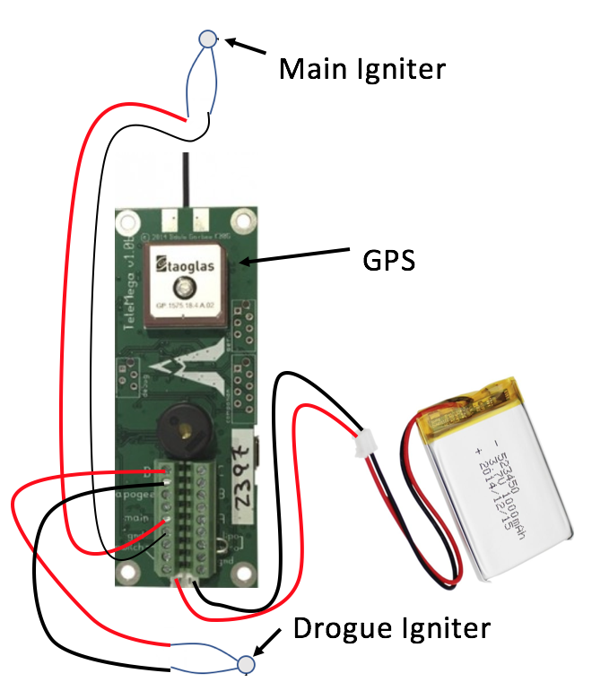

Figure 2. Electronics schematics of the Telemega GPS

## Electronics Test Plan and Preliminary Results

On previous rockets, we tested the RRC3 altimeter by hooking a vacuum up to the body tube to decrease the pressure read by the altimeter. When it reached a max pressure and began to stop (what happens just after apogee), the altimeter would wait one second and then ignite a black powder capsule to deploy the parachutes. With higher quality electronics, the Telemega is able to bypass the more complex and dirty pressure test to simply hold the rocket vertically and thrust it upward quickly to fool the altimeter into thinking it was launched. After a preprogrammed amount of time (2 seconds for our competition rocket after launch), the Telemega would send a signal to our sustainer igniter to light the engine. After apogee and most of its descent, when the Telemega senses that the rocket has passed an altitude of 1,000 feet with a negative velocity, it would again ignite another charge to pressurize our sustainer body tube to deploy the two parachutes.

Before launch, we sync the GPS (part of the Telemega) with nearby satellites. The GPS not only tracts where the rocket lands but it also records the rockets flight data so we can consider the actual flight path of the rocket and compare it to the simulations we programmed last year to optimize the final rocket. From there we can address the differences between the simulation and the actual data to further our simulation accuracy after the competition.

So far, we have only been able to test the Telemega GPS connection, and the successful ignition of igniters we made. During the week of September 17th, we plan to test the opening of our small and main parachute in the sustainer body tube using very fine gun powder and an electrical spark made from the Telemega. Last year, we were able to master the software of the Telemega (with many mistakes) to ensure we understand it enough to ensure a safe and successful flight with full recovery.

# Safety and Launch Procedure Checklist

## Launch Operations and Safety Precaution Checklist

1. Assemble Launch Pad in desired location given the rocket flight path, wind direction and field orientation
   1. If the wind is strong in a certain direction, and angle of attack can be useful to compensate for the calculated drift the rocket
   2. Set up the launch rail stopper to raise the rocket roughly 6 inches above the launch pad base
   3. Slide rocket into position on rail
2. Turn on the Telemega GPS to begin satellite connection and flight configuration
   1. Ensure battery is fully charged and beeps sound when switch is flipped on
3. Turn on SEDS Altimeter by connecting the terminals on the side
   1. Ensure correct beeps upon startup
4. Insert the booster engine assembly into the booster
   1. Ensure that there are no possible situations that can ignite the booster engine when configuring on the launch pad
5. Screw rocket aft retainer onto engine tube
6. Remove yellow safety cap to begin igniter installation
   1. Ensure that the range safety officer and the launch director are the only ones at the pad to limit the amount of people around the rocket
   2. All other members and observers must be 100 feet away from the rocket
7. Install igniter leads into engine by inserting through the nozzle and up the grain until it reaches the top
8. Screw engine casing retainer onto the booster engine tube to constrain the engine in both the positive and negative y directions
9. Attach igniter leads onto the launch system alligator leads.
   1. Check that the other igniter launch leads are not connected to the battery and the launch director has the launch key
10. Insert the sustainer engine assembly into sustainer engine tube.
    1. Ensure that there are no possible situations that can ignite the sustainer engine when configuring on the launch pad
11. Screw rocket after retainer onto engine tube
12. Remove yellow safety cap to being igniter installation
13. Install pre-installed igniter leads from e-bay into the engine.
    1. Insure proper lead connections between the e-bay and ignitor wire
14. Install igniter leads into engine by inserting through the nozzle and up the grain until it reaches the top
15. Screw engine casing retainer onto the sustainer engine tube to constrain the engine in both positive and negative y direction
16. Re-attach sustainer, coupler, and booster tubes.
17. Perform final checks on the rocket
    1. Fin alignment between stages
    2. Proper retainment on all engines
    3. Correct pin installations if needed
18. Run from launch pad (It is UNH SEDS tradition to always run from the launch pad before countdown)
19. Verify TeleMega connection, continuity on all igniters and GPS tracking
20. Setup launch controller to the battery for launch
21. Verify surroundings and safety of all people
    1. Launch safety officer must give the okay for launch
22. Check continuity
23. Countdown --> Launch
24. If Launch is unsuccessful, disconnect leads from battery
    1. Disconnect alligator clips from ignitor leads
    2. Remove ignitor leads from engine
    3. WAIT 60 seconds
    4. Problem solve the issue

# Results Analysis

The bulk of our work leading up to this report was to become acclimated to the science of rocketry. As we near our launch date, we began the final manufacturing and assembly of our competition rocket.

## Material Choice

Carbon fiber offers a lightweight and strong selection for material, despite its material cost. All major rocket components can be purchased with proper tolerances to ensure the perfect fit for each part. The centering rings, bulk plates and nose cone will be manufactured in house. The centering rings and bulk plates could be cut from 1/8-inch carbon fiber sheets we have available, but with limitation in how we can manufacture it to size, we had to go with ½ inch thick acrylic laser cut using our local makerspace. With Solidworks, we were able to ensure that the acrylic is comparable to the carbon fiber at this thickness and configuration. It was also calculated that it only increased weight by an insignificant amount (<10%). During the first week of the Fall semester, we immediately began the printing of a female mold to fiber glass the nose cone. This was a new skill to all of us, so there was a large learning curve. We found it hard to keep the layers of fiberglass even throughout and the final result was not axially symmetrical. Having a non-symmetrical nose cone could have cause extreme issues in stable flight and we didn’t want to risk the entire rocket on a skill we only started to develop. Ultimately, we used a 3D printed PLA nose that was sanded down for smoothness. Although an ABS nosecone would prove to be structurally stronger and less prone to deformation from outside pressures, we did not have the printer capable of printing in ABS available to us. We decided to also 3D print our fins exactly to size, and then added two layers of fiberglass for strength and the avoidance of fin flutter. As we continue building newer and better rockets, in house composite manufacturing will improve naturally.

## Engine Choice

The engines that have been used to increase our body of knowledge in rocketry were G class. The biggest transition that will occur from the flight of our competition rocket will be the addition of total impulse to the rocket. We have done work on handling the bigger high power engines with our Static Test Fire Rig that showed us first-hand the kick these engines provide. The integration of these larger competition engines requires stronger centering rings, and an overall rocket build capable of travelling at faster speeds. This lead us to go with carbon fiber, a stronger composite then the rocketry standard, blue tube, and thicker centering rings with more precise and experienced epoxy fillets. When reinforcing the sustainer centering rings with thicker layers of epoxy, we mistakenly forgot to insert the wire leads for sustainer ignition through the slots we made to easily solder the igniter section for the engine and the wire leads to the Telemega. This has required us to order a 1/8-inch extended drill bit (12 inches long) so we can reach into our body tube and make the necessary cuts to reopen our slots from the epoxy.

## Parachute Choice

The parachute research and testing we have completed has given us a base of knowledge that was easily transferable to our competition rocket. A major change from our original design report, the negation of our drogue parachute, was chosen mainly to ensure the rocket gets down to sight level as soon as it can. We will be incorporating a small, drogue-like parachute with our main parachute, folded in a way to ensure the drogue opens first. With the extra strength of 1000 lb. Kevlar shock cord, professionally made parachutes and reinforced centering rings, we have calculated that the force from two separate parachutes opening at different times does not have the required strength to break any critical components to lead to failure.

# 

# Failure Analysis

## Improvement Cycle for Failure Mitigation

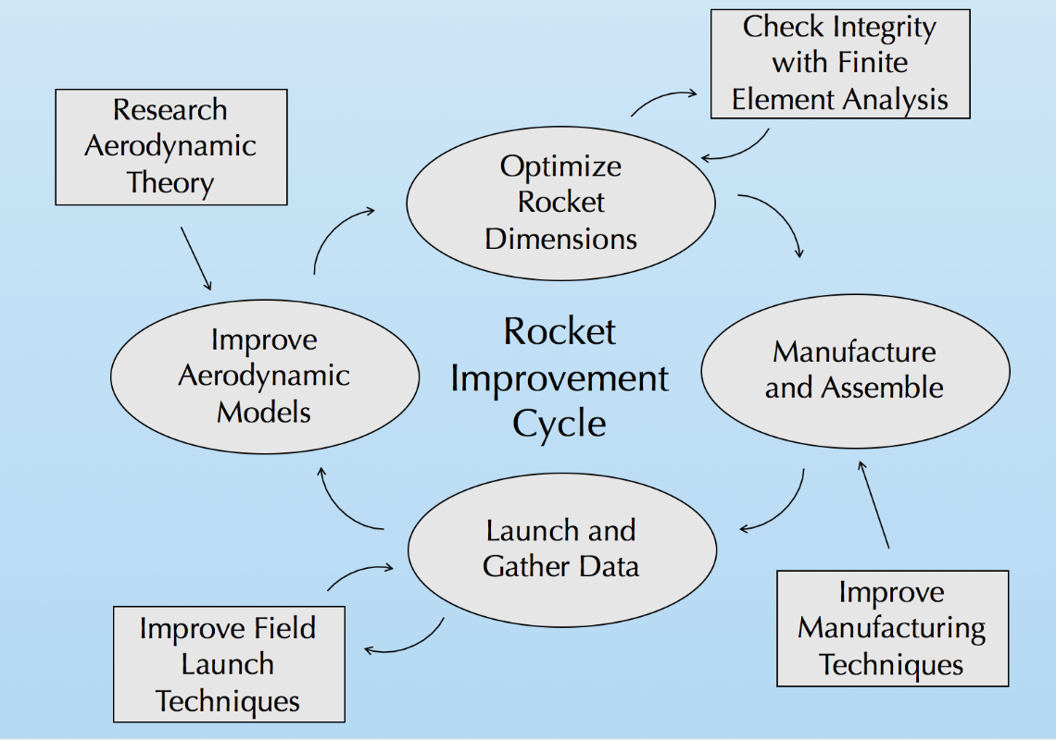

Figure 3. Improvement Cycle

Our team utilized an improvement cycle to ensure progression and improvement on each rocket iteration to ensure each flight becomes more successful and safer. The cycle begins with research of aerodynamic theory to enhance our aerodynamic models used for flight simulations. When the flight simulations are validated with experimental data, rocket dimensions are optimized for max altitude. This is done using a nonlinear optimization program in MATLAB. These dimensions are constantly checked with finite element analysis to ensure structural integrity with a minimum factor of safety of 3. This safety of factor was chosen purely to mitigate the error that we predict of a new rocket team. In the future, we would like to lower this factor of safety closer to 1.5. The rocket is then manufactured with the optimal dimensions, while working to employ better techniques from last build. After the rocket is manufactured, it is launched, and data is gathered. We are always pursuing better launch techniques to ensure recovery of all components. The data from the flight is reviewed and compared to our flight simulations, where the process then repeats.

The SEDS competition rocket is our most precise and strongest rocket ever made. It is the 9th rocket we have made, and is the last of its Aether class, Aether VII. This improvement cycle, which has been modified and improved over the 2017-2018 school year, has helped us continue to improve with each build, preventing senseless mistakes and encourages us to improve.

## Failure Mitigation Safety Checks

One of the first problems that we needed to solve was an excessive roll during flight due to the method we used to attach and align the rockets fins. In order to improve upon our design and further mitigate possible sources of error, the team created an alignment tool for the fins out of acrylic. The cross-sectional shape of the body tube and fins was laser cut into a piece of acrylic with a minimal offset to create an evenly spaced holster for manufacturing.

# Multimedia Documentation

The launch took place in South Berwick, ME, on September 29th mid-day. Below are the links to the videos taken during the launch, and an assortment of pictures of the beautiful day.

## YouTube Links

The link below is the video that tracked the booster as it landed with its recovery system. Nothing broke at landing, allowing for full recoverability of our booster.

<https://youtu.be/qhKtFAfzMnM>

The link below tracked the sustainer, but quickly went out of sight as it reached its apogee. Recovery of the sustainer could not be recoded as it drifted over a kilometer into a nearby lake. Data was still collected through the Telemega transmitting to our computer on the field.

<https://youtu.be/kTArgz6VOts>

## Notable Pictures

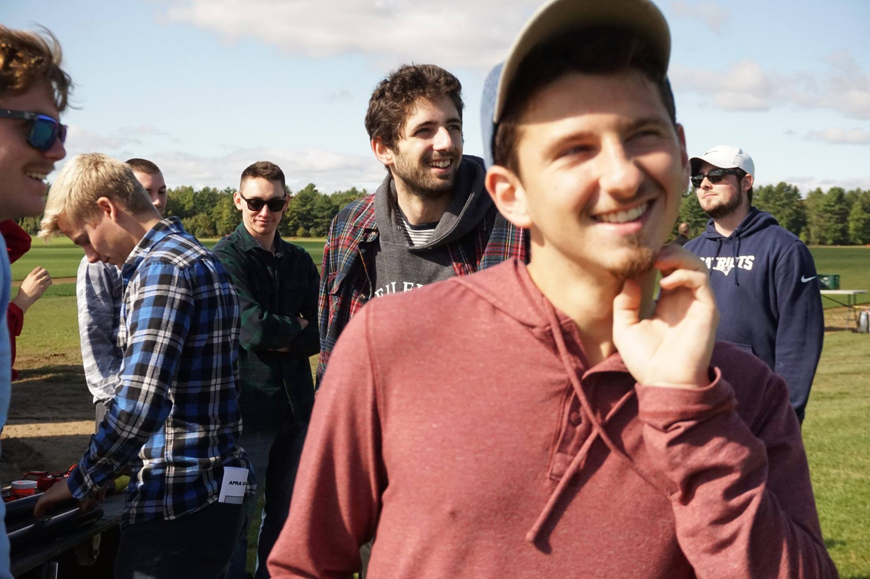

Figure - Team members enjoying the launch day and preparing the rocket for launch

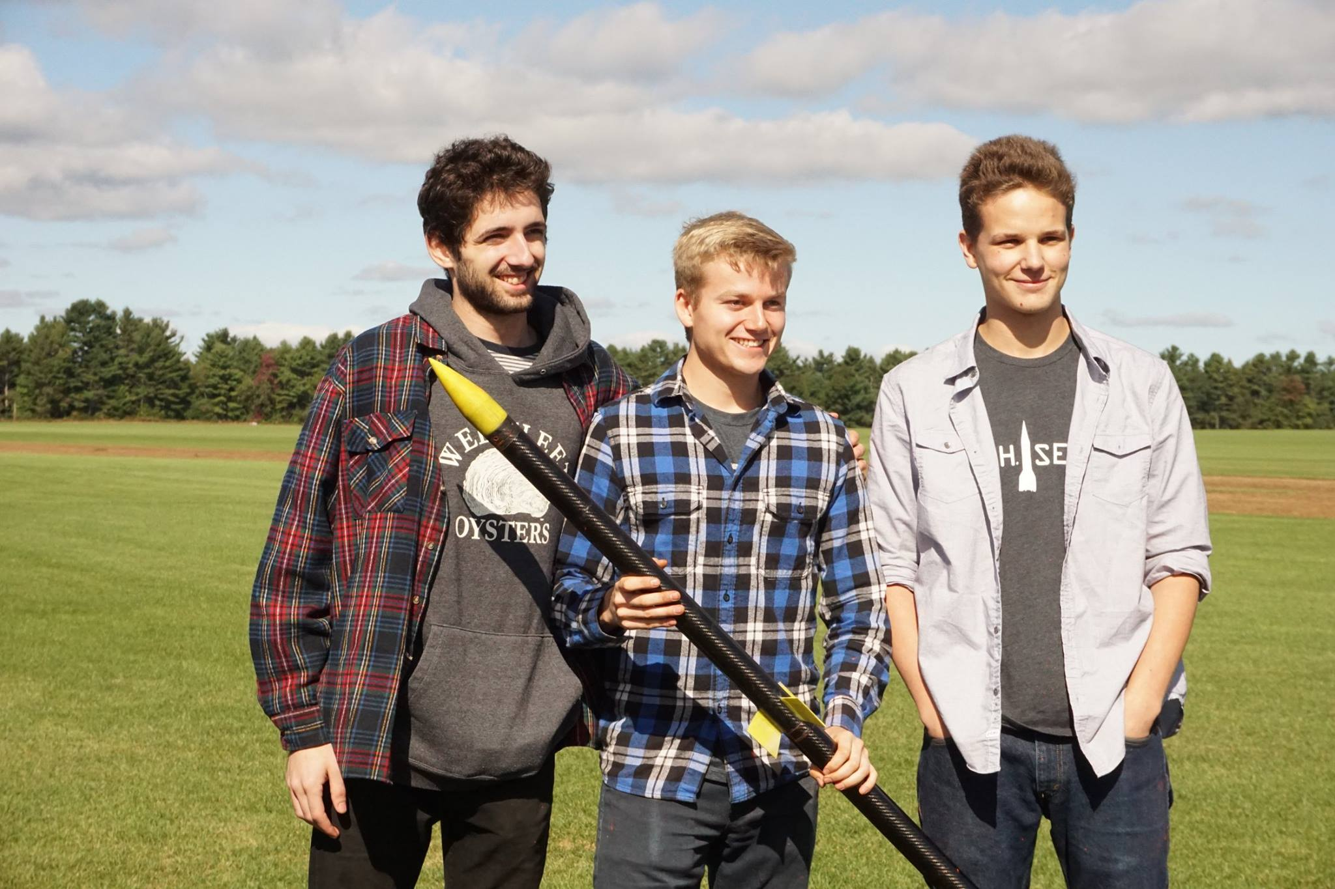

Figure - Engineering and building leads confirming rocket is go for launch

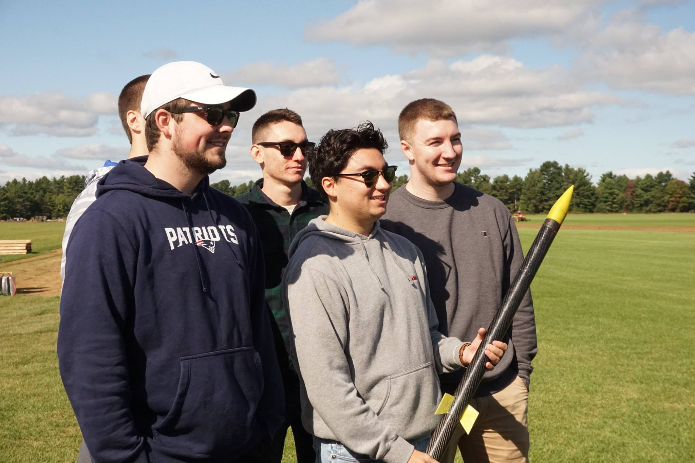

Figure - The new seniors of the club experiences their first rocket launch

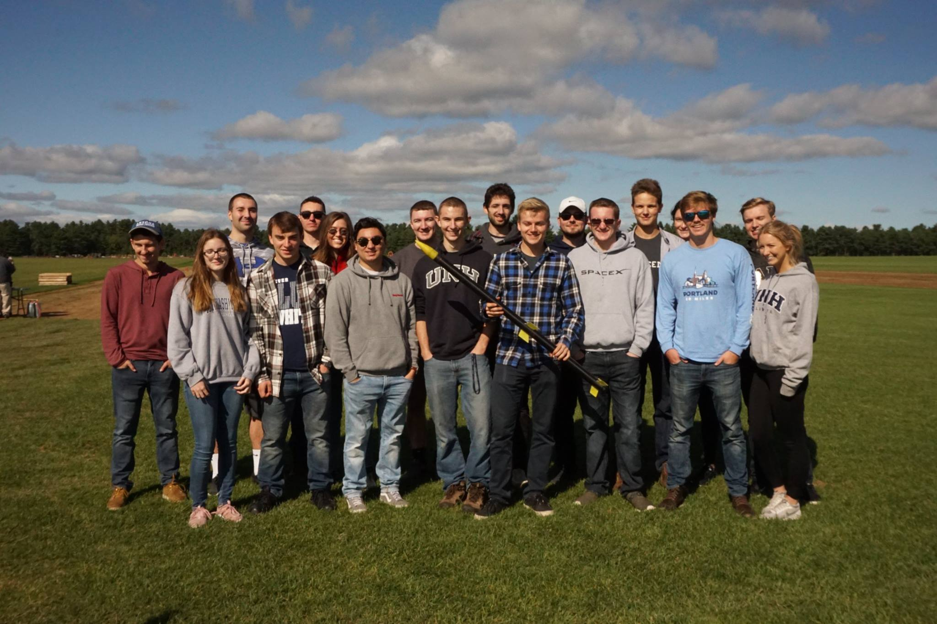

Figure - Full team picture as we approach our launch time

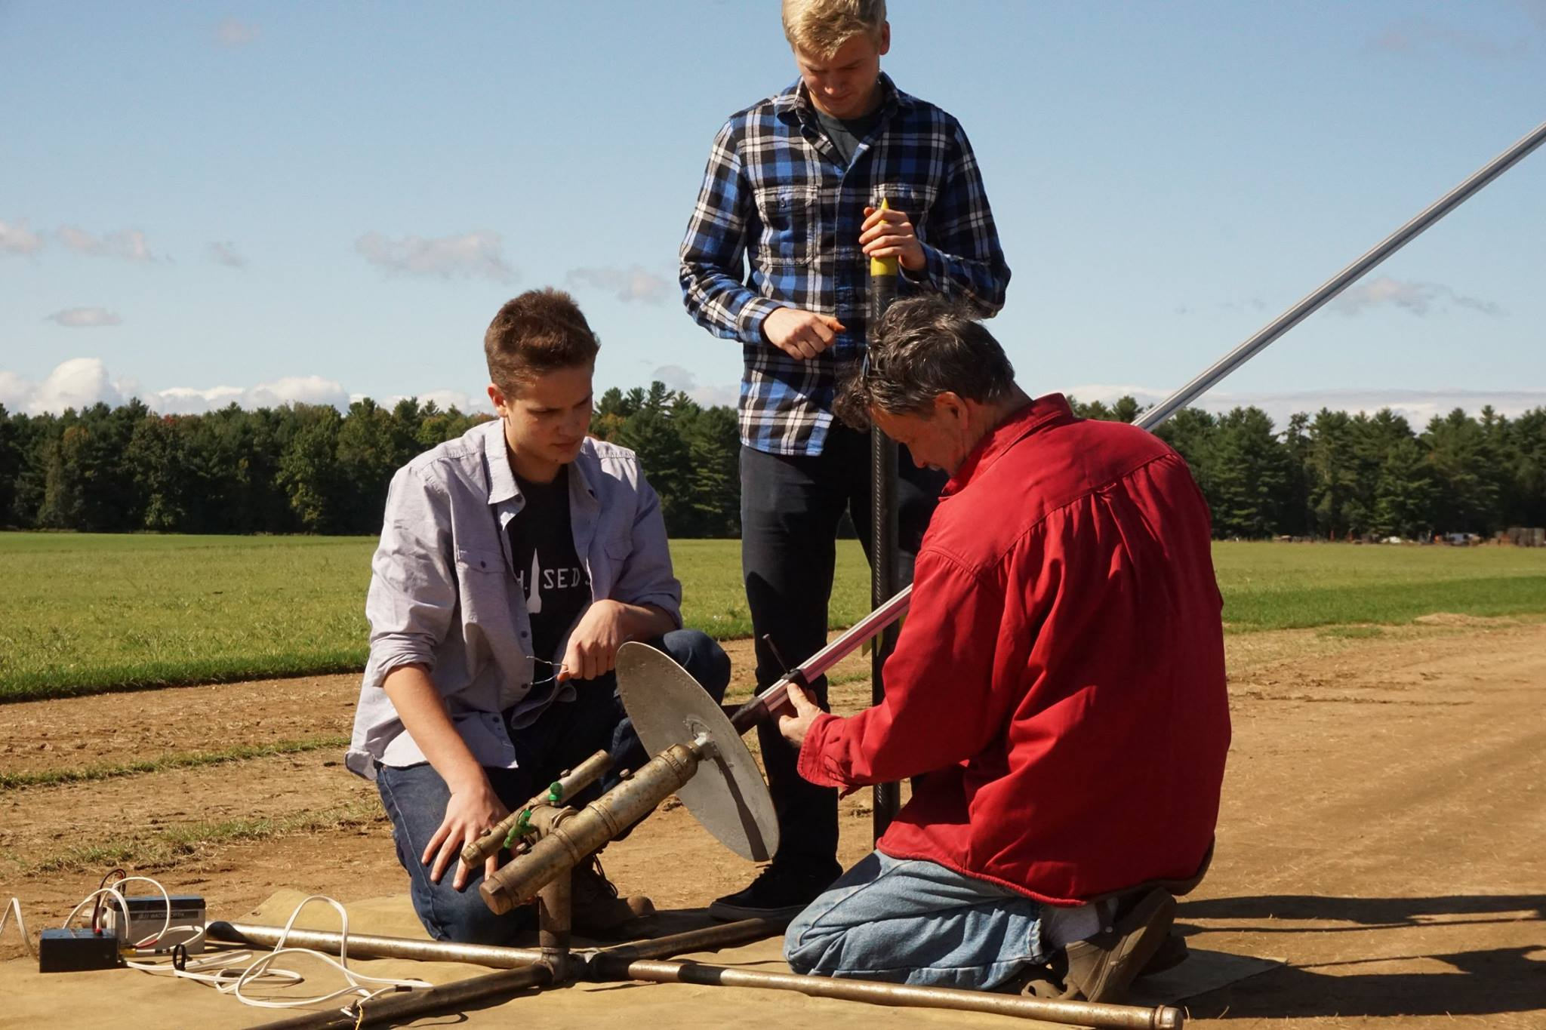

Figure - Attaching the multi-stage rocket to the launch pad

# APPENDIX

## MATLAB Simulation Code

The following code details the functions used to accurately optimize a two-stage rocket with specific known constrains. The code can be easily manipulated with different constraints, such as stability, diameters, and masses. The parent function, utilizing MATLAB’s Fmincon, converges on the dimensions of every part of the two-stage rocket to increase its final output: max altitude.

### Fmincon

#### 